HMAP Dataset 14

Galapagos Marine Reserve, Ecuador II

Supporting Documentation

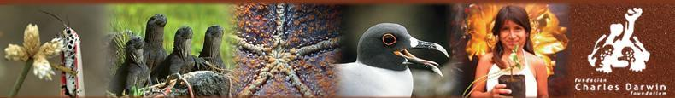

Summary

Dataset Title: Galapagos Marine Reserve, Ecuador II

Large Marine Ecosystem: 11: Pacific Central-American Coastal

Subject: Catch and effort statistics, sea cucumber, spiny
lobster and finfish fisheries since 1961

Data Provider: Mauricio Castrejón, M. Sc.
Charles Darwin Research Station
Galapagos, Ecuador
mcastrejon@fcdarwin.org.ec
maucm26@yahoo.com.mx

Data Editor: David J Starkey, MHSC, University of Hull
d.j.starkey@hull.ac.uk

Extent: 15000 records

Keywords: Historical statistics; INCOFISH WP2; Galapagos
Marine Reserve; sea cucumber; spiny lobster, finfish
fishery; Participatory Programme of Fisheries
Monitoring and Research (PIMMP)

Citation:
(a) The dataset: please cite as follows: M. Castrejón, J. Moreno & C. Peñaherrera ‘HMAP Galapagos Marine Reserve, Ecuador II’, in D.J. Starkey & J.H. Nicholls (comp.) HMAP Data Pages (www.hull.ac.uk/hmap)
(b) Supporting documentation: please cite as follows: M. Castrejón, J. Moreno & C. Peñaherrera ‘HMAP Dataset 14: Galapagos Marine Reserve, Ecuador II, Supporting Documentation’ D.J. Starkey & J.H. Nicholls (comp.) HMAP Data Pages (www.hull.ac.uk/hmap)

2. Research Context & Objectives

The Galapagos Islands straddle the Equator in the Pacific Ocean about 1000 km west of mainland Ecuador. There are 19 islands, which, together with 107 islets and volcanic rocks, cover a total land area of 8010 km² with 1666.6 km of coastline. It is located at the convergence of three major seasonally varying current systems: the Humboldt (from the southeast), the Cromwell (from the west) and the North Equatorial (from the northeast) currents. Their confluence let cold water species like penguins co-exist with tropical species such as reef coral or hammerhead sharks. In addition, Galapagos is featured by its high proportion of endemic marine species (ca 18.2% on average) and by the strong influence “El Niño” has on the abundance and distribution of species and habitats, particularly over reef coral and macro-algae beds. Currently, there are approximately 19,184 people inhabiting 3% of the total land area of Galapagos Islands. The human population lives in three main districts (cantones): Santa Cruz (58.7%), San Cristóbal (32%) and Isabela (9.3%).

The Galapagos archipelago and its surrounding open ocean are enclosed in a marine reserve of nearly 133,000 km², the Galapagos Marine Reserve (GMR). It is a multi-use reserve, where tourism and fishing are permitted. It was created in 1998 through the approval of the Special Law of Galapagos (SLG). At the same time, the SLG excluded the foreign and national “industrial” fishing fleets from the GMR. Since then the fishing activity is exclusive to the local small scale artisanal fleet. In addition, the SLG established a co-management system, which was institutionalized through the creation of the Participatory Management Board (PMB) and the Interinstitutional Management Authority (IMA). Both are fora, where local stakeholders can participate in the decision-making process along with the Galapagos National Park (GNP), the institution in charge of the management of the GMR.

A high diversity of marine species is commercially harvested in Galapagos. These include invertebrates of high economic value such as sea cucumber (Isostichopus fuscus) and spiny lobster (Panulirus penicillatus and P. gracilis), as well as several demersal and coastal and migratory pelagic finfish species (ca. 65 species). However the Galapagos grouper (Mycteroperca olfax) has been traditionally the most important marine resource since the beginning of the commercial fishing activity in Galapagos in 1920. A wide variety of methods and fishing gears are used such as hooka diving, handline, beach seine, gill net, hook and line, etc.

In October 2007, there were 1023 fishermen registered by the GNP. However, the number of full-time and part-time fishermen varies between 323 and 466. Most fishermen (50.8%) live in Puerto Baquerizo Moreno on San Cristobal Island, the rest live in Puerto Ayora on Santa Cruz Island (25.6%) and Puerto Villamil on Isabela Island (23.6%). There are 447 artisanal fishing vessels registered, most common are fibreglass boats approximately 5 to 9.5 metres in length. The fishing industry employs approx. 3.6% of the active economic population (AEP) and its contribution to the Galapagos gross domestic product (GDP) is approximately 1.9% ($US 3.2 millions).

Several tools to improve fisheries management have been developed, discussed and implemented since the creation of the GMR. These include the Management Plan for the Conservation and Sustainable Use of the GMR, Coastal Zoning, the 5-Year Fishing Calendar (2002-06), and the Fishing Registry. However, in spite of such efforts, the co-management system of the GMR is not accomplishing the main objective for which it was created – sustainability of resource use. The sea cucumber and lobster populations, which represent the main fishery resources of the GMR, have showed signs of overexploitation. Unemployment and social instability have increased, and credibility and participation in the co-management system have declined.

This situation was perceived as critical by the members of the PMB, who in May 6th 2005 pronounced the need to “begin a process in the PMB and IMA to change the current management model of the allowed activities in the GMR towards a more appropriate and sustainable model, that allocates the fishing effort according to the capacity of the resource and that diversifies the resources which are exploited in the GMR”. This agreement was ratified by IMA members who asked the PMB “to seek the necessary technical assistance, to carry out an evaluation of the GMR fishery management and to formulate a more appropriate and sustainable fishery management model”.

In this context, researchers of the Charles Darwin Foundation (CDF) adapted and made use of a method called Participatory Fisheries Stock Assessment (Parfish) to evaluate the current co-management system of the GMR and to formulate a new fisheries management plan. In order to determine the effectiveness of the current management framework to encourage the sustainable development of the GMR fisheries, evidence relating to pre-1998 levels of fishing effort and catches was required. The CDF working group - in the context of INCOFISH WP2 - undertook research to establish the historical baselines of the three most important fisheries of the GMR: 1) the finfish fishery (locally known as “pesca blanca”); 2) the spiny lobster fishery and 3) the sea cucumber fishery. The data gathered and presented in Dataset 54 were used to determine the past and current status of these fisheries. The information obtained was discussed and analyzed jointly with representatives of the artisanal fishing sector and managers of the GMR in order to agree on the future management objectives, indicators, reference points, decision rules and management strategies for the new fisheries management plan.

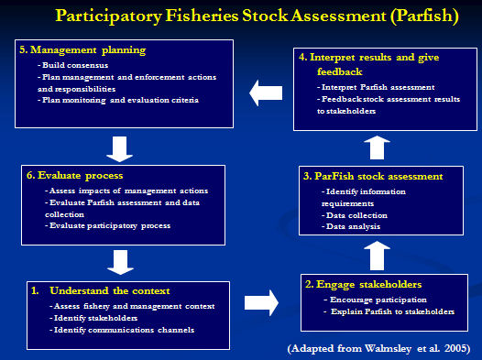

3. Primary Source Materials

Although commercial fishing activity commenced in Galapagos during the 1920s, it was not until 1997 that the systematic collection of fishing and biological data was initiated by the newly-founded Participatory Programme of Fisheries Monitoring and Research (PIMMP). Since then, the PIMPP has collected on a daily basis site-specific catches and effort data for the main fisheries of the GMR. Consequently, a large and complex amount of fishing related data has been generated. All this data was reviewed, standardized and edited by researchers of the CDF between March 2005 and December 2007. In addition, a range of primary source material was used to assemble pre-1997 data on the sea cucumber, spiny lobster and finfish fisheries. Thus Dataset 54 has been generated as follows:

1) Sea cucumber fishery: data relating to catch and effort have been assembled from published papers, official reports and the PIMPP database from 1992 to 2005. This time period cover the entire history of this fishery in Galapagos.

2) Spiny lobster fishery: data relating to catch, effort and catch-per-unit-effort have been assembled from theses, field reports and the PIMPP database from 1961 to 2006.

3) Finfish fishery: data relating to catch (including ca. 65 species) and effort has been assembled from theses, field reports and the PIMPP database from 1977-2006.

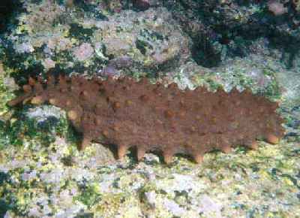 | 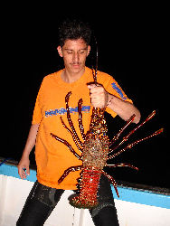 | 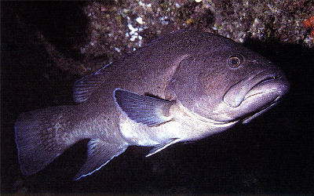
Sea Cucumber | Spiny Lobster (red) | Galapagos Grouper

4. Metadata: Explanation of Data Fields

The entries below are outlined as per the field headings of HMAP Dataset 14. An explanation is offered for each field in general terms, and also in dataset specific terms.

ID
ID is the unique, consecutive serial numbers for the complete HMAP database.

CDF_ID
This is the CDF's own set of serial numbers that is unique to the database of the Participatory Fisheries Monitoring Programme (1997-2006).

InstitutionCode
InstitutionCode is the name given to the overall project of which this Dataset forms a part (HMAP).

CollectionCode
CollectionCode is the specific HMAP project Dataset reference code (used for OBIS referencing purposes).

DateLastModified
This is the date when the data were last modified.

CASE_STUDY
CASE_STUDY is the location identifying description of the Dataset. In this instance: Galapagos Marine Reserve, Ecuador.

DATASET
DATASET is the HMAP project unique Dataset reference.

PERIOD
The Historical Period covered.

ID_NUMBERS
This field contains the range of record numbers shown in the ID field.

REFERENCE
REFERENCE refers to the source of records employed in the research.

publication_date
This is the date when the Dataset was published.

GENERAL_DESCRIPTION
This is a brief description of the Dataset.

Citation
Citation is the field where the formal attribution is shown for users of the HMAP Datasets to cite; it credits the researchers and editors of a Dataset together with its database compilers. This citation must be quoted whenever records are referenced or employed for any purpose.

Please quote the relevant citation when using extracts or details from this Dataset:

- M. Castrejón, J. Moreno & C. Peñaherrera, ‘Galapagos Marine Reserve, Ecuador II’, in D.J. Starkey & J.H. Nicholls(comp.) HMAP Data Pages (www.hull.ac.uk/hmap)

BasisOfRecord
BasisOfRecord is the abbreviation applied that indicates whether the record is based on observations (O), living organisms (L), specimens (S), germplasm/seeds (G), photos (P), or from literature with original basis unknown (D); the HMAP value is generally 'O'.

OCEAN_REGION
This field indicates the specific Ocean Region where the Dataset research has been carried out. If this field shows 'None', then the research reflects activities carried out in non-seaward locations (e.g. in rivers, weir fishing, etc.). In this Dataset, the Eastern Tropical Pacific region was researched.

LME
This field indicates the name of the Ecosystem where the record event occurred. To find out more about LMEs (which are confined to continental shelf regions) browse the Large Marine Ecosystem site (http://www.edc.uri.edu/lme/) where LME GIS data may be downloaded. In this Dataset, the Pacific Central-American Coastal region was researched.

LME_NUMBER
This field indicates the number of the LME that is shown in the previous field. In this Dataset, the LME number is 11.

ISLAND
This field indicates which specific Island of the Galapagos Marine Reserve is the centre of the survey for a particular record.

GROUND
This field indicates the fishing ground(s) where organisms were effectively caught.

LATITUDE
The LATITUDE refers to a mean value of the species distribution from surveys and should be cross referenced with the LONGITUDE field for specific location determination.

LAT_PRECISION
This gives the actual precision of the calculated LATITUDE field. The available options are:
- Approx Approximate position
- Estimated Estimated position
- Exact Exact position
- Ground Centre Notional centre of the relevant fishing ground
- Unknown Position not known

LONGITUDE
The LONGITUDE refers to a mean value of the species distribution from surveys and should be cross referenced with the LATITUDE field for specific location determination.

LON_PRECISION
This gives the actual precision of the calculated LONGITUDE field. The available options are:
- Approx Approximate position
- Estimated Estimated position
- Exact Exact position
- Ground Centre Notional centre of the relevant fishing ground
- Unknown Position not known

ST_YEAR
This field refers to the start year of the beginning of the fishing activity.

EN_YEAR
This field refers to the end year of the end of the fishing activity. Unless the fishing activity spanned an extensive period, this value is usually the same as the ST_YEAR field entry.

ST_DATE
This field refers to the date fishing activity commenced.

EN_DATE
This field refers to the date fishing activity concluded.

ST_TIME
This field refers to the time fishing activity commenced. This is important in determining the difference between various daytime periods of observations (e.g. morning, afternoon, night, etc.)

EN_TIME
This field refers to the time fishing activity concluded. This is important in determining the difference between various daytime periods of observations (e.g. morning, afternoon, night, etc.)

Observer
This field specifies if the vessel had a fishery observer aboard and is simply shown as YES or NO.

Vessel_Name
This field depicts the name of the fishing vessel.

Vessel_Type
This field depicts the type of the fishing vessel. Types referenced include:
- Fiber glass: Artisanal fiber glass small boat between 5m to 9.5m
- Wooden boat: Artisanal wooden small boat between 3.1 m to 10.6 m
- Boat: Wooden boat between 8 to 17.5 m. The only exception is “El Salvador”,
boat of 30m long
- Unknown: Vessel type (if a vessel was even used) is not known

HOME_PORT
This is the home port of the fleet employed in the fishing process.

Effective_Fish_Days
This field indicates the number of days during which fish were effectively caught.

Effective_Fish_Hours
This field indicates the number of hours during which fish were effectively caught.

Number_Divers
This is the number of divers who were involved in the fishing process.

Method
This field indicates the fishing method or gear by which fish were caught.

LocalName
This field indicates the local name of the species under investigation.

ScientificName
This field indicates the scientific name of the species under investigation which is linked to the INCOFISH related FISH BASE database containing detailed information about the species that were sampled.

FamilyName
This field indicates the family name of the species under investigation.

Observed_Weight
This is the Empirical Weight (in kilogrammes) of the catch.

Weight_Measured_Estimated
This field specifies whether the total weight was measured or estimated. Typical values are:
- Measured
- Estimated
- Unknown

PROCESS
This is a description of the process applied to the catch; it specifies whether the whole animal was retained or whether the tail was retained. It reflects on the Observed_Weight of the catch.

Preservation
This is a description of the preservation method applied to the catch. It reflects on the Observed_Weight of the catch.

Catch_N
This is the actual number of animals caught. Where this data is not available, a value of "unknown" is entered.

Catch_Measured_Estimated
This field specifies whether the Catch Number (Catch_N field) was measured or estimated.

GENDER
This field indicates the Gender of the species in the sample. The values available are shown as follows:
- 'M' male
- 'F' female
- 'U' unknown
- 'B' both male and female
- 'H' hermaphrodite

CPUE
The CPUE field (Catch Per Unit Effort) is a calculation of the Catch Amount (in kilogramms) divided by the "Effort" (determined from the number of fishing trips taken and based upon the unit of effort used) expended in the process. For this dataset, accurate CPUE data is not available for all data due to limited or insufficient information about the Effort expended on fishing trips.

NOTES
The NOTES field gives detailed information specific to a particular record. The details are provided to clarify specific entries and where further explanation is required than is generally provided in this METADATA file. For complete and academically verifiable explanations, refer to the published research materials that are indicated in the REFERENCE field.

5. Outputs

Castrejón M (In preparation) El sistema de co-manejo pesquero de la Reserva Marina de Galápagos: situación actual y propuestas de cambio. Charles Darwin Foundation, Galapagos, Ecuador.

Castrejón M, Larrea S, Gravez V, Chalen X, Murillo JC, Gaibor N, Reyes H, Martínez R, Oviedo M (2007). Capítulo Pesca del Plan de Manejo de la Reserva Marina de Galápagos, primer borrador. Technical Commission of the Participatory Management Board, Galapagos, Ecuador.

Peñaherrera C (2007) Variaciones espacio-temporales de los ensambles de peces en la Reserva Marina de Galápagos, basados en registros pesqueros. Bachelor thesis. Pontificia Universidad Católica de Ecuador, Quito, Ecuador.

Enquiries regarding the information contained in this document and the accompanying dataset should be directed to David J Starkey (d.j.starkey@hull.ac.uk) or John Nicholls (j.nicholls@hull.ac.uk).

